Teachers’ Day Card Reflection

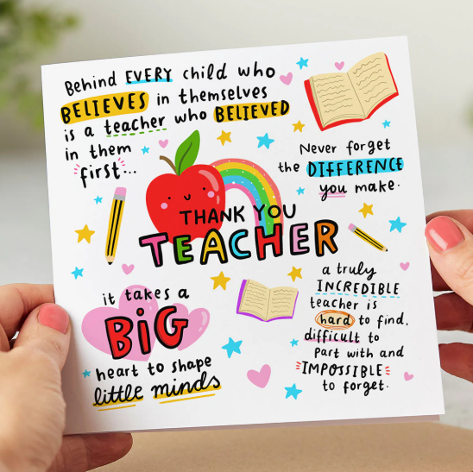

Overview
The Teachers’ Day card-making activity was a joyful and meaningful opportunity to express gratitude while strengthening important learning skills. By designing personalized cards filled with colorful artwork and heartfelt messages, we celebrated the role teachers play in shaping our growth, confidence, and curiosity. The experience blended creativity, collaboration, and reflection into a memorable moment of appreciation.

My Process
As a group, we brainstormed ideas, discussed themes, and divided responsibilities. Some of us focused on illustrations, others on writing messages, and many supported both. Throughout the process, we exchanged feedback, solved small challenges, and ensured that every card communicated respect and thankfulness. Working together helped us stay organized and encouraged everyone to contribute their strengths.

Impact on Personal Growth
Creating the cards helped me better understand the importance of gratitude and empathy. I reflected on how my teachers guide me academically and personally, and I became more aware of the value of acknowledging their efforts. Sharing appreciation openly built my confidence and strengthened my ability to express positive emotions.

Impact on Professional & Academic Development
The activity strengthened collaboration, planning, and time management. I practiced communicating ideas clearly, listening to others, and adapting when needed. These are essential skills not only in school projects but also in future professional environments where teamwork and respect are highly valued.

Connection to the IB Learner Profile
This celebration supported several IB Learner Profile attributes:
- Communicator – We expressed appreciation through thoughtful words and visual design.
- Caring – The cards were created with genuine gratitude and respect for our teachers’ dedication.
- Principled – We recognized the importance of acknowledging the contributions of others.
- Open-minded – We welcomed different artistic ideas and perspectives within the group.
- Balanced – The event combined creativity, emotion, and community building.

Connection to Approaches to Learning (ATL) Skills
The experience also nurtured key ATL skills:
- Communication Skills – sharing ideas, giving feedback, and writing meaningful messages.
- Social Skills – cooperating, resolving disagreements, and supporting teammates.
- Self-Management Skills – organizing materials and completing tasks within the timeline.
- Thinking Skills – generating creative designs and making decisions together.

Conclusion
The most powerful moment of the celebration was seeing the happiness and appreciation on our teachers’ faces as they received the cards. It reminded me that even small gestures can create a lasting impact. Beyond the artwork, the experience became a lesson in gratitude, teamwork, and community. It is a memory that continues to inspire how I show appreciation and collaborate with others in both my personal and academic life.

